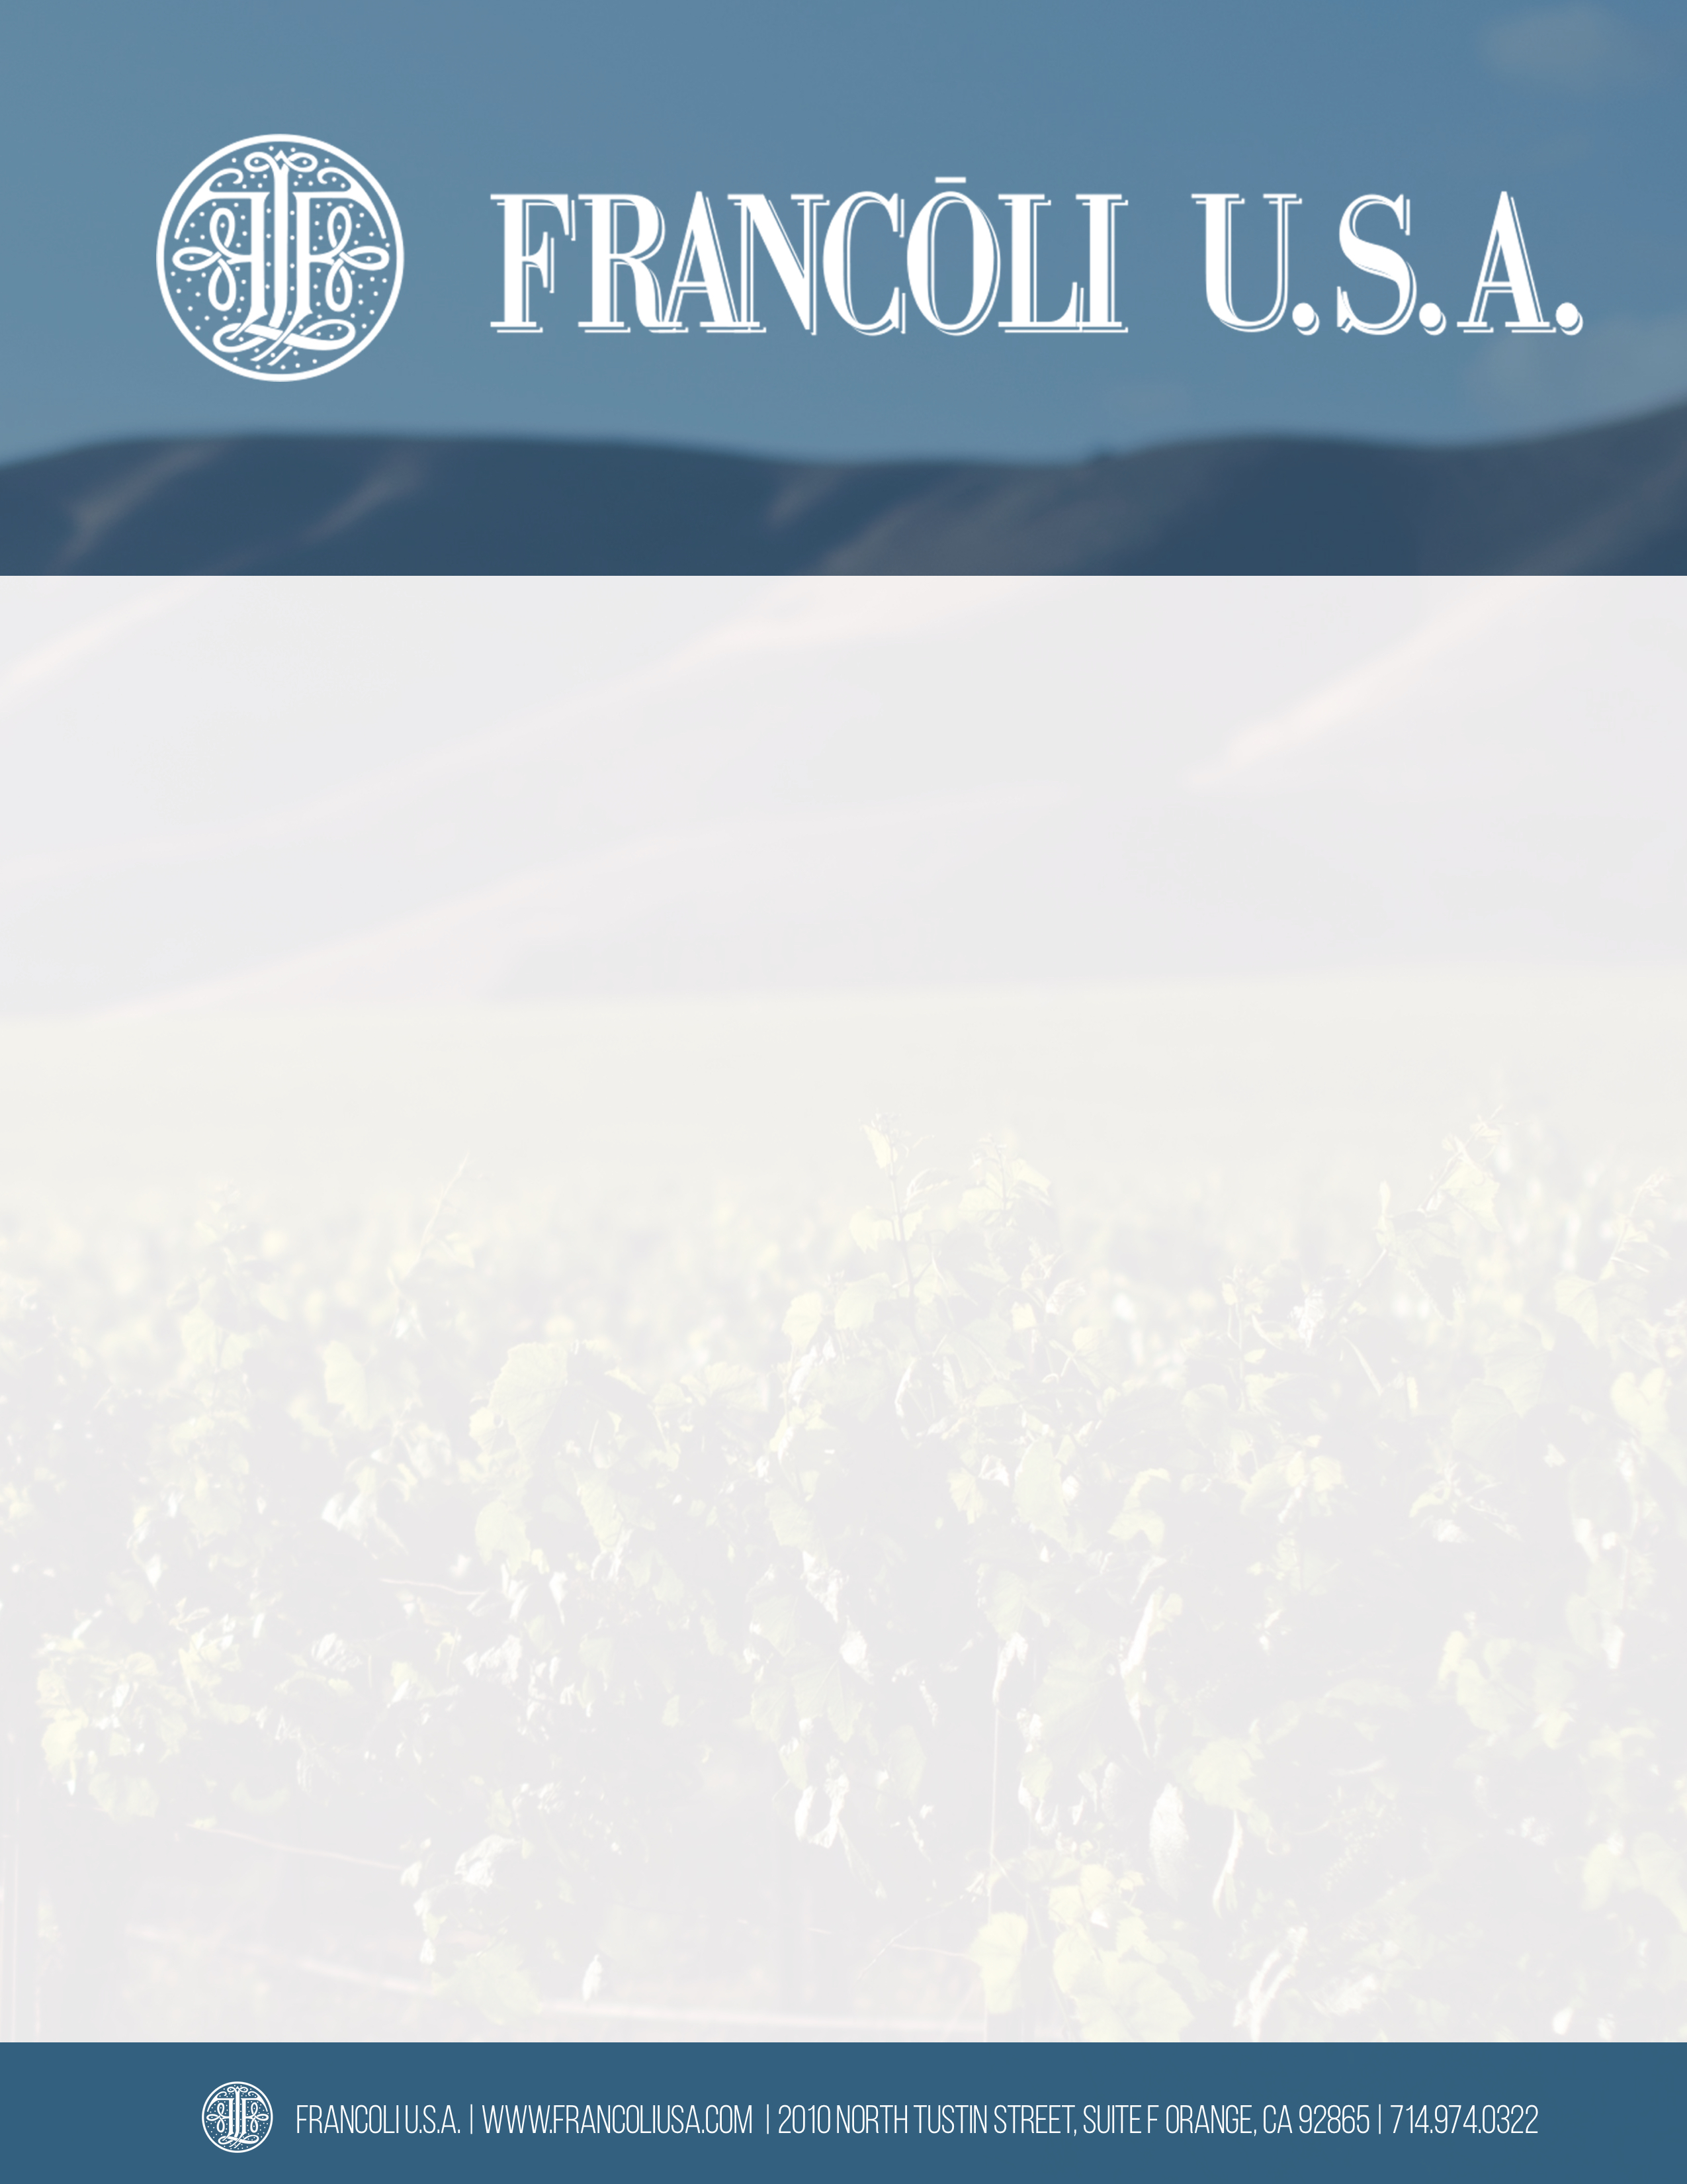

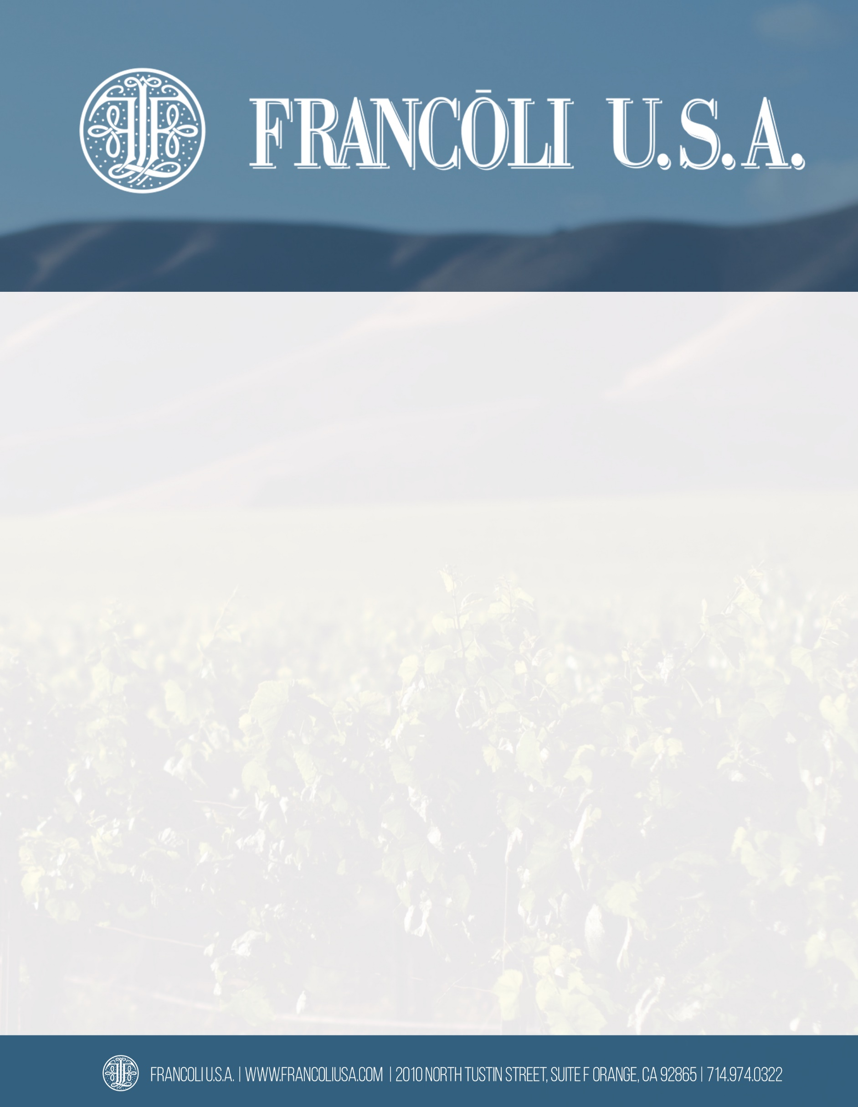­­­­­

**NOTTOLA VINO NOBILE DI MONTEPULCIANO**

Vino Nobile di Montepulciano is a classic Italian wine grown in the hills of Montepulciano, Tuscany. The blend must be at least 75% Sangiovese and can include other local varieties such as Canaiolo or other varieties permitted in Siena. It must be aged for a minimum of 24 months, at least 12 months in oak.

**REGION:** Tuscany

**APPELLATION:** DOCG

**VARIETAL:** 95% Sangiovese, 5% Merlot

**ALCOHOL:** 14%

**WINEMAKING:**

Soil Composition: Clay/Limestone 6 ft. Deep

Vine Training Method: Spurred Codon

Elevation: 1,100 ft.

Vine Exposure: South West

Harvest Time: Late September

Fermentation Container: Stainless Steel

Length of Alcoholic Fermentation: 20 Days

Malolactic Fermentation: Wood

Type of Aging Container: Wood

Type of Oak: 3,000 Liter Slovenian

Length of Aging Before Bottling: 24 Months

Months Length of Bottle Aging: 12 Months

**TASTING NOTES:**

Ripe fruit including blackberry and raspberry with spices. It has a gently tannic tea- leaf finish. The tannins are firm and the wine has a structured acidity good for ageing.

**FOOD PAIRINGS:**

Wild game Ragu, salami, pork sausages, and roasted lamb. Roasted wild mushrooms with polenta.

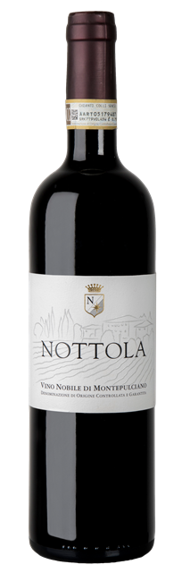

AWARDS:

Gardini Notes 90+ Points 2015 vintage

Wine Enthusiast 90 Points 2015 vintage